The app folder seems to have standard permissions

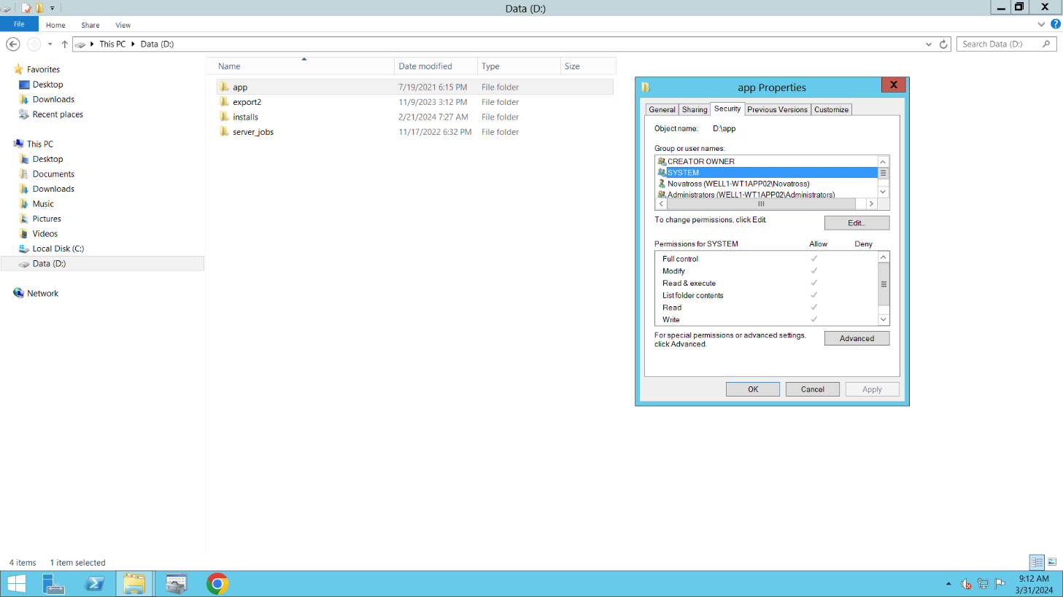

But d:\app\wt1\tablet\reports folder gives **Users special permissions…**

